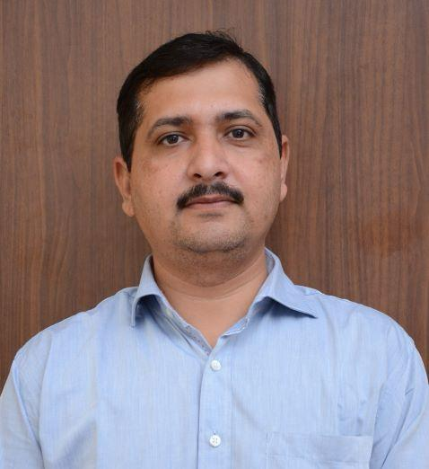

Mr. Dushyant Chouhan
CFO

Mr. Dushyant Chouhan is currently holding the position of Chief Financial Officer in IKLL.
He is an Associate Member of the Institute of Chartered Accountants of India and holds Information Systems Audit (ISA) certification from ICAI, in addition to Bachelor of Commerce degree.
He commenced his professional career in IFFCO Kandla Unit as Financial Management Trainee, in 2005 and currently holding position of Head of Finance & Accounts Department at IFFCO Kandla Unit.

